SOP for validating submissions

Document Owner | Aina Jené - CEGA Operations Manager (CRG)
Contributors | Name(s) - Role(s)/Title(s)
Version | 1.0
Effective date | DD-MM-YYYY
Approvals | Name(s)
Next revision due | DD-MM-YYYY

Purpose
With the launch of the new Submitter Portal, once a user completes a submission (meaning, they register at least one dataset) then they click the “Finalise” button. After sending the submission to be finalised, the submission is not automatically accepted by EGA, and as a result, it is not immediately provided with accession IDs. Instead, the submission is sent to the Helpdesk team for manual validation before the accession IDs are assigned. This process is in place to prevent the inclusion of dummy DAC data in the database and to minimise object duplication, while promoting the reuse of DACs whenever feasible.

Scope
This document aims to provide the EGA Helpdesk team with a comprehensive understanding of how to validate submissions through the Helpdesk Portal created using the new Submitter Portal.

Procedure

- Log in to the Helpdesk Portal and go to “SUBMISSIONS”. You will see the following information: Submission info, Studies, Samples, Experiments, Runs, Analysis, Datasets, Files, Submitter, Updated, Created

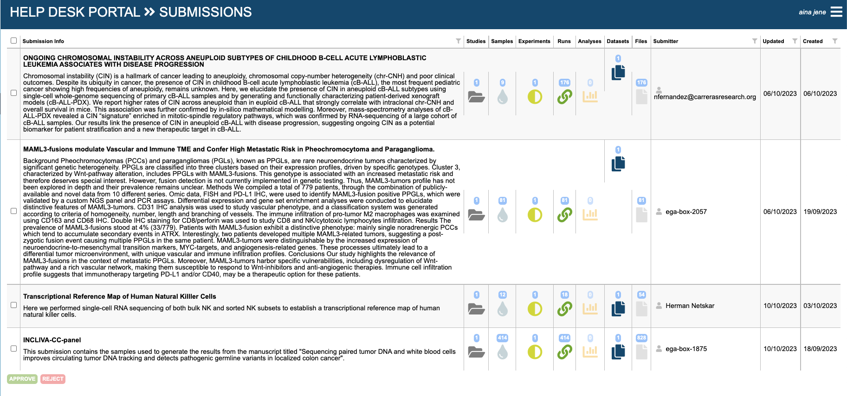

- For each object check:
  - Submission
    - This information is not public. Any information in this section can be accepted.
  - Studies
    - Study title is expected to be a 3-20 word introduction of the project.
      - IF the title is approximately this length, THEN it can be accepted.
      - IF the title is too short/long or doesn’t make sense, THEN reject the submission and ask the submitter to update/change the title and re-finalise the submission.
    - Study description is expected to be a 3-5 sentences definition of the project with some background, goals, and details.
      - IF the description aligns with these expectations, THEN it can be accepted.
      - IF the description does not align with these expectations (e.g. it is a copy of the title, it doesn’t describe the “why” of the study), THEN reject the submission and ask the submitter to update/change the description and re-finalise the submission.
  - Samples
    - Samples MUST NOT contain personally identifiable information. This can include: names, national ID numbers, addresses.
      - IF the samples do not contain personally identifiable information, THEN they can be accepted.
      - IF the samples contain personally identifiable information, THEN reject the submission and ask the submitter to remove all personally identifiable information and re-finalise the submission.
  - Experiments:
    - There is currently nothing to check for Experiments.
  - Runs
    - File extensions must be correct for a Run object (fastq, bam, cram…).
      - IF the file extensions are all in the approved list for a Run object, THEN they can be accepted.
      - IF there are file extensions not in the approved list for Runs, THEN reject the submission and ask the submitter to update the extensions and re-finalise the submission.
  - Analyses
    - File extensions must be correct for an Analysis object (vcf, phenotype file…)
      - IF the file extensions are all in the approved list for an Analysis object, THEN they can be accepted.
      - IF there are file extensions not in the approved list for Analyses, THEN reject the submission and ask the submitter to update the extensions and re-finalise the submission.
  - Dataset
    - Dataset title is expected to be a 3-20 word description of the dataset content.
      - IF the title is approximately this length, THEN it can be accepted.
      - IF the title is too short/long or doesn’t make sense, THEN reject the submission and ask the submitter to update/change the title and re-finalise the submission.
    - Dataset description is expected to be a 3-4 sentences definition of the dataset content, including sample number and details, file type, and technology/experimentation used.
      - IF the description aligns with these expectations, THEN it can be accepted.
      - IF the description does not align with these expectations (e.g. it is a copy of the title, some of the metrics don’t match what was submitted), THEN reject the submission and ask the submitter to update/change the description and re-finalise the submission.
    - If the submitter is an ega-box, make sure that the DAC used in the dataset is from the same ega-box.
      - IF Submitter and DAC are from the same ega-box, THEN it can be accepted.
      - IF the Submitter and DAC are not from the same ega-boxes, THEN reject the submission and add a comment asking if the dataset should be managed by a DAC from a different account and contact the Helpdesk team for further assistance.
    - If the submitter is an EGA account (not ega-box), check if the contacts in the DAC are linked to the organisation of the submitter.
      - IF Submitter and DAC are from the same organisation, THEN it can be accepted.
      - IF the Submitter and DAC are not from the same organisation, THEN reject the submission and add a comment asking if the dataset should be managed by a DAC from a different organisation and contact the Helpdesk team for further assistance.
- IF any of the objects in the submission are rejected according to the descriptions above, THEN reject the entire submission following this SOP for approving/rejecting a submission (Step 3b) and provide feedback to the submitter based on which Objects were rejected through an RT ticket.
- Once all objects in the submission are accepted according to the descriptions above, THEN approve the entire submission following this SOP for approving/rejecting a submission (Step 3a) and contact the submitter informing that the submission is now accepted through an RT ticket.

